Meet the Sta 101 TA’s + Our Office Hour Tips

## Evan Knox evan.knox@duke.edu Head TA

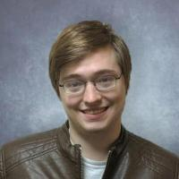Howdy everyone, I'm Evan!  I'm a PhD student from Athens, GA, by way of the University of Georgia.  Some of my interests that relate to this class include designing undergraduate statistics classes and communicating probabilities to the public.  Outside of statistics, I spend my time playing board games, competing in trivia contests, and watching college football.

My main advice would be to be mindful about what you want out of office hours and what (if anything) you need to put in beforehand to make that work best.  If you work best going through a problem asking small, clarifying questions when you get to something ambiguous, feel free to come right in and work on it.  If you're looking for a more full explanation of a topic or feel like something just isn't making sense with the rest of the material, it may make sense to strategically work ahead or back a little bit so that you have a probing question or two to fall back on in case your TA doesn't understand the mental conflict you're having.

## Joe mathews joseph.mathews@duke.edu

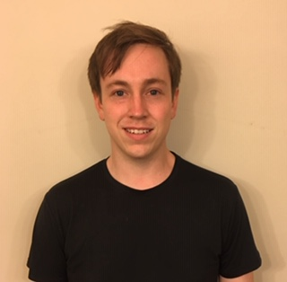Hi, my name’s Joe and I’m a PhD student in the statistical sciences department! I’m originally from Clarksville, TN and I like dogs and playing music.

Students should try to ask precise questions in office hours so that we can answer their questions efficiently. They should expect TAs to guide them towards the correct solution.

## Emre Yurtbay emre.yurtbay@duke.edu

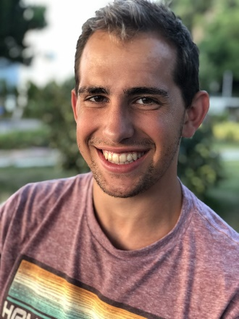Hi everyone! My name is Emre Yurtbay, and I am a Master's student in the Statistical Science program. I received my undergraduate degree in Statistics from Rice University, and I enjoy running, drawing, and playing soccer.

I look forward to getting to know many of you this semester during TA office hours! Even though they will be virtual, don't hesitate to contact me or any of the other TA's with questions about the material and the homework problems.

## Thea Dowrich thea.dowrich@duke.edu

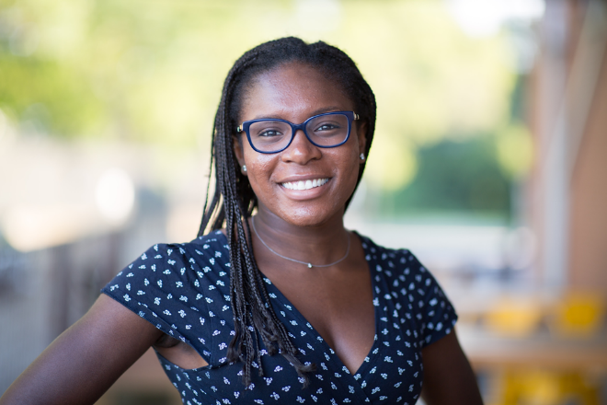Hi everyone, I’m Thea and I am a senior majoring in Public Policy with double minors in Chemistry and Statistics. My family and I have been living in Tokyo for the past 5 years, but I was born in Barbados and lived in Connecticut for most of my life. Outside of Duke, I love travelling and trying new restaurants in Durham!

With regard to the tips about office hours: It's largely a student-driven time, so they should come with questions prepared, but there aren't any restrictions on what questions they can ask, except maybe "What is the answer?" We can't give them the answers, but we can guide them through the problem and work through the process together and pinpoint where they are having difficulty.

## ALINA FENG ALINA.FENG@duke.edu

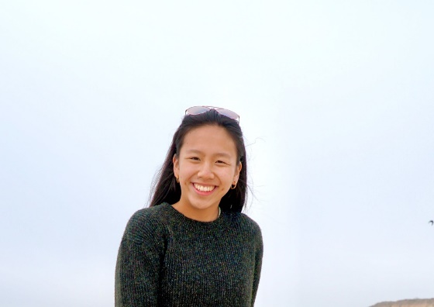My name is Alina Feng, and I'm a sophomore from the Bay Area, CA studying Biology and Stats. I love to go on runs, read, or paint during my free time! Office Hours are a great time to ask clarifying questions while getting to know the TA and different paths you can take in Stats! Feel free to stop by and ask questions not just on the material but also ways to engage with Statistics as a field.

## Carly Grossfield carly.grossfield@duke.edu

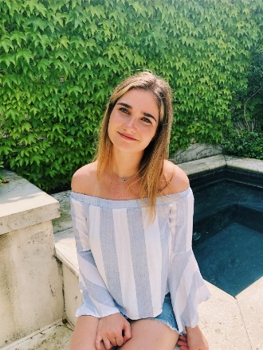My name is Carly Grossfield, and I am a sophomore at Duke. I am from Bethesda, Maryland right outside of Washington, DC. I am majoring in Economics with a finance concentration and minoring in Spanish.

I think the most effective way to utilize office hours is by coming prepared with questions and taking time before to try to understand the material.

## Nadia Innab nadia.innab@duke.edu

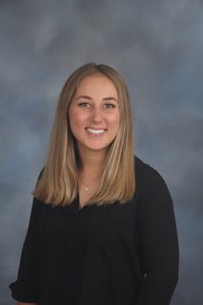My name is Nadia and I am a senior from Los Angeles, California majoring in Public Policy with minors in Statistics and Gender, Sexuality, and Feminist Studies. In my free time, I love baking, running, and watching Friends!

A piece of advice I have for attending office hours is to come with questions prepared, because it makes the time more productive!

## SIMONE NABORS simone.nabors@duke.edu

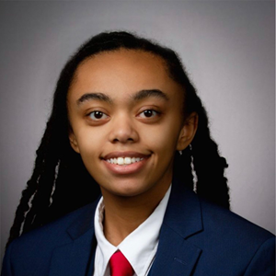Hello, my name is Simone (she/her), and I am a sophomore from Wake Forest, NC majoring in Neuroscience with minors in Chemistry and Photography all on the pre-med track. I am particularly interested in improving access to healthcare, specifically for the LGBTQ+ community, as well as storytelling. In my free time I love to travel, read, and learn about new things, whether that be how to solve some sort of puzzle or a random fact that I will likely never need to know.

My biggest piece of advice regarding office hours is to use them! If you’ve been stuck on a concept/question and have already done your best to find the solution based on the text and lecture materials, don’t hesitate to come to office hours to ask for help. In general, it is best to come with specific questions, and we can work from there.

Compiled by Emily Gentles and Jacob Smith